Ideation Phase

Empathy Map Canvas
Date: 02 November 2025
Team ID: NM2025TMID03190
Project Name: Laptop Request Catalog Item
Team Members: Indra & Buvana
Maximum Marks: 4 Marks

The Empathy Map Canvas helps to understand the user’s mindset, needs, and experiences while interacting with the laptop request process. It provides insights into their emotions, behaviors, and challenges to guide the design of an effective ServiceNow Laptop Request Catalog Item.
Who are we empathizing with? | We are empathizing with employees who need to request laptops for their work. They can be new hires, existing staff, or remote workers requiring replacement devices.
What do they need to do? | They need to request a new or replacement laptop through a convenient and quick process. They should be able to track the request status and receive notifications without depending on multiple emails or manual follow-ups.
What do they see? | Employees see delays in laptop approvals and a lack of transparency in the request process. They observe inconsistent communication from different departments such as HR, IT, and procurement.
What do they say? | They often express frustration about the slow process and uncertainty about request status. They might say things like, 'I don’t know when my laptop will be approved' or 'I had to follow up many times.'
What do they do? | They send multiple reminder emails to managers or IT staff, check with HR for updates, or even escalate delays. Some employees use personal devices temporarily, affecting productivity.
What do they hear? | They hear from colleagues that the process is slow and requires manual effort. Managers might mention workload issues, and IT staff may highlight challenges in tracking requests.
Pains | • Long waiting times for approval and delivery.  • No visibility into the status of laptop requests.  • Repeated follow-ups cause frustration.  • Lack of clarity on approval responsibilities.  • Difficulty in using personal devices temporarily.
Gains | • A faster, automated request and approval process.  • Real-time visibility of request progress.  • Notifications for every stage of the workflow.  • Reduced dependency on manual communication.  • Better coordination between departments.

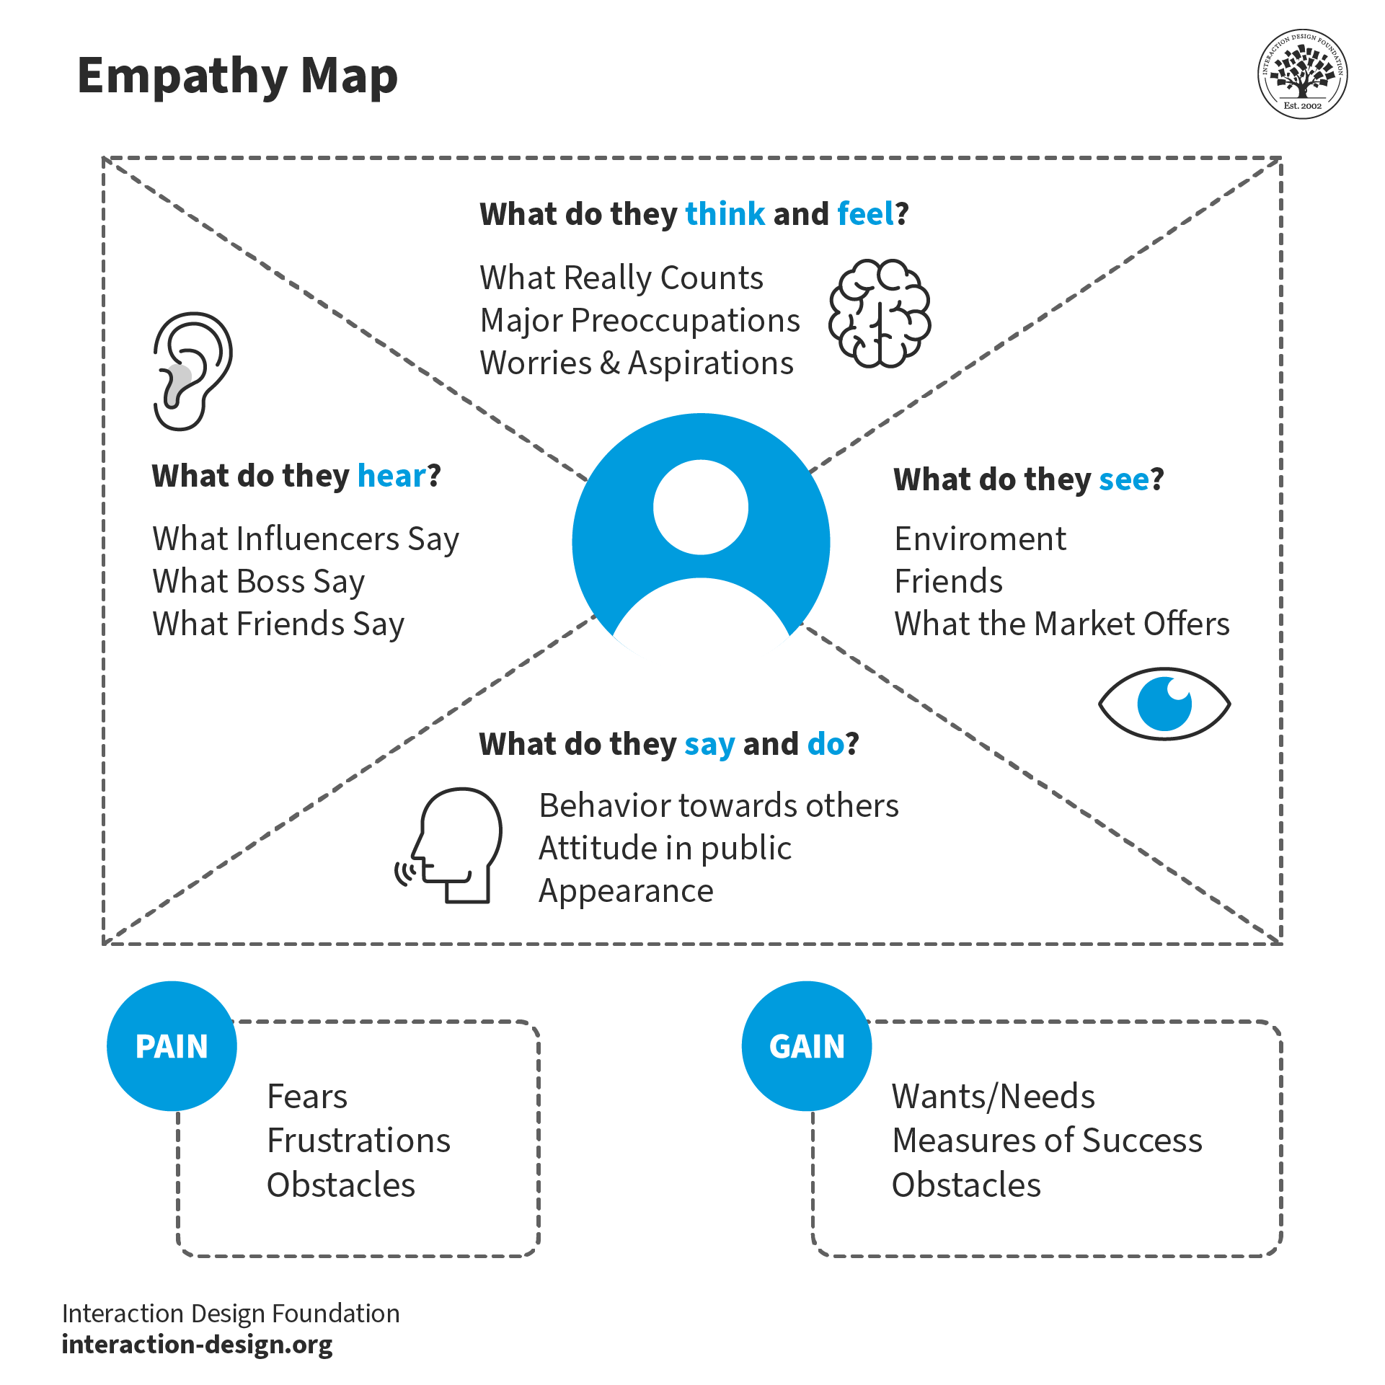
By understanding the employee’s needs, emotions, and challenges, the team can design a Laptop Request Catalog Item that is user-friendly, efficient, and transparent. This empathy map guides the team to build features that truly solve user pain points.

